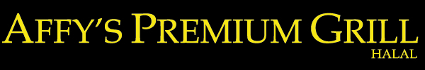

BANQUET HAL PARTY PACKAGE

PARTY FOR ALL OCCASIONS, FROM 50 TO 200 GUESTS
PER PERSON $35
APPETIZERS:
Chicken Wings, Spring Rolls, Crispy Fried Lemon Fish Fingers
MAIN COURSE:
Main course: Roast Prime Rib Steak, Choice of one Chicken Dish, filet of Sole, BBQ Short Ribs, Chicken Parmesan, Rice, Roasted Potatoes, Salad, and dinner Rolls W/ Garlic Butter
DESSERTS:
Brownies, Tiramisu & Fresh Fruits Platter
DRINKS: Pop

PACKAGES IS SUBJECT TO 15% GRATUITY AND APPLICABLE TAXES

